**TAKE NOTICE** that the Town of Huntsville has received an application for a Class 2 Community Planning Permit. To facilitate the development proposed in this instance, minor relief is needed from one or more of the applicable requirements of the Town of Huntsville Community Planning Permit By-law (By-law 2022-97, as amended). Details about this application including its purpose and effect and the lands affected are described below and are available online at <https://www.huntsville.ca/business-development-environment/planning-and-development/planning-notices/>.

**APPLICATION NO.:** CPP/37/2025/HTE

**OWNER(S):** Williams

**ADDRESS:**  584 Skyhills Road**LEGAL DESCRIPTION:** Part of Lot 3, Concession 5, Former Geographic Township of Chaffey, being Part 1 on Plan 35R-17033; Town of Huntsville, District Municipality of Muskoka

**PURPOSE AND EFFECT:** The applicant proposes to permit the construction of a 139.3m2 detached two-storey garage, with a 139.3m 2 Secondary Residential Dwelling Unit (SRDU) on the second storey. A Class 2 Community Planning Permit is required to:

* Permit a Secondary Residential Dwelling Unit (SRDU) on a lot with the Rural Residential (RR) precinct that does not meet the RR lot area requirements;
* Increase the permitted gross floor area of a Secondary Residential Dwelling Unit within a detached accessory building from 75m2 to 139.3m2; and
* Permit development within an area of Steep Slopes.

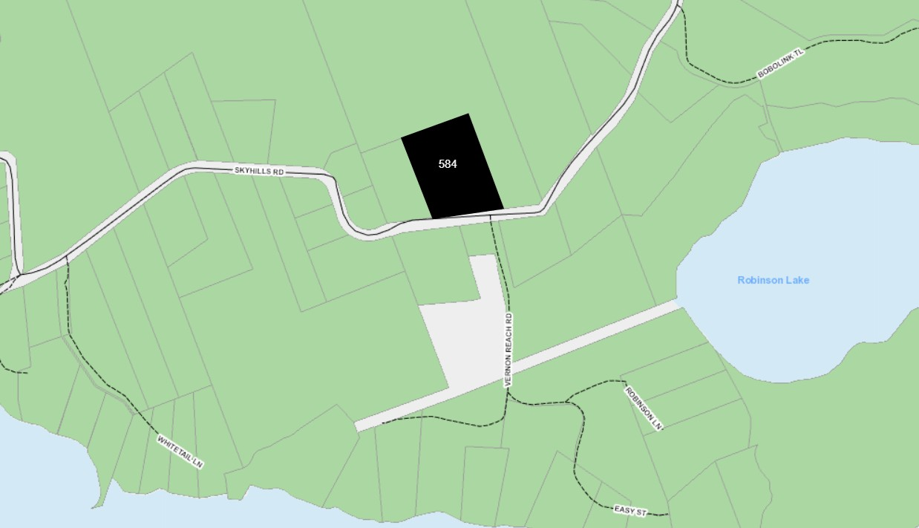

Members of the public wishing to comment must make a written submission within 14 days of this notice by contacting the Town’s Planning Department using the contact information provided below. ***Please take note that any objections must include your name, contact information and reasons for your objection***.

A decision on this application will be made **NO EARLIER THAN Friday, September 12, 2025.** Any submissions regarding this application must be made in writing before this date.

**PLEASE NOTE:** All comments and submissions received will become part of the public record. Comments received as part of the public participation process for this proposal will be considered by the approval authority.

Plans and an explanation of this application can be obtained by contacting the Planning Department using the contact information below.

**FOR MORE INFORMATION** about this matter, contact the Town of Huntsville Planning Department**:**

37 Main St. E, Huntsville, ON. P1H 1A1**IN-PERSON:** 8:30a.m. to 4:30p.m.

**TELEPHONE:** (705) 789-1751 (Ext. 2422)

**EMAIL:** [planning@huntsville.ca](mailto:planning@huntsville.ca)

**WEBSITE:** [www.huntsville.ca](http://www.huntsville.ca)

**NOTICE DATE: August 28, 2025**

**SKETCH:**

